ROTARY CLUB OF GLENELG INC.

CLUB 17676 - DISTRICT 9520

ANNUAL REPORT

2018 – 2019

Service to the Community since 1952

Meeting Venue Postal Address
The Holdfast Hotel P.O. Box 158
83 Brighton Road Glenelg S.A. 5045
GLENELG S.A. 5045
Time: 6:15 for 6:30 p.m.

E-Mail: rotaryclubofglenelg@gmail.com
Web Page: www.rotaryclubofglenelg.com including Facebook

CONTENTS

Contents | 1
Our Objectives & Mission of Rotary International | 2
Our Heritage | 3
Past Presidents | 5
Board of Directors | 6
Club Membership During 2016-2017 | 7
Membership of District Committees | 8
District Conference & District Assembly Attendees | 8
District Committee members | 8
President’s Report | 9
Club Administration Report | 15
Community Service Report | 16
Membership Report | 20
Foundation Report | 21
Fellowship Report | 22
International Service Report | 24
Youth Report | 26
Fundraising Report | 29
Club Meeting Programmes | 30
Finance Report | 34

Meridith Beaston with David & Pam Binks - Editors of Glenelg Rotary Club Annual Report

OUR OBJECTIVES

The object of Rotary is to encourage and foster the ideal of service as a basis of worthy enterprise and, in particular, to encourage and foster:

First

The development of acquaintance as an opportunity for service;

Second

High ethical standards in business and professions; the recognition of the worthiness of all useful occupations; and the dignifying of each Rotarian’s occupation as an opportunity to serve society;

Third

The application of the ideal of service in each Rotarian’s personal, business and community life;

Fourth

The advancement of international understanding, goodwill, and peace through a world fellowship of business and professional persons united in the ideal of service.

The RI Board has agreed that the four explanatory statements in the Object of Rotary are of great and equal significance and are actions that must be taken simultaneously.

Mission of Rotary International

The mission of Rotary International, a worldwide association of Rotary clubs, is to provide service to others, promote high ethical standards, and advance world understanding, goodwill, and peace through its fellowship of business, professional, and community leaders.

Now summarised as

“Doing good in the world”

ROTARY CLUB OF GLENELG PAST PRESIDENTS

1952-1953 Arthur Wenzel
1953-1954 Owen Bowering
1954-1955 Geoff Ford
1955-1956 Jack Chaston
1956-1957 Jack Hoeper
1957-1958 Stan Fereday
1958-1959 Blair Lake
1959-1960 Ron Lloyd
1960-1961 Rex Hart
1961-1962 Neil Oldfield
1962-1963 Angus Neill
1963-1964 Clive Nettleton
1964-1965 Blair Ferguson
1965-1966 Tom Raggatt
1966-1967 Colin Steele
1967-1968 Andy Stompe
1968-1969 John Hepton
1969-1970 Don Crawford
1970-1971 Murray Western
1971-1972 Rod Kerr
1972-1973 Graeme McKenney
1973-1974 Ivor Lewis
1974-1975 Lance Lee
1975-1976 Ray Mattiske
1976-1977 John Gibbs
1977-1978 Terry Edwards
1978-1979 Neil Wight
1979-1980 John Hardy
1980-1981 Len Greenslade
1981-1982 Henry Burrows
1982-1983 Bill Rufus
1983-1984 Jim Chantrell
1984-1985 Peter Heysen
1985-1986 Graham Gillies

1986-1987 Geoff Norman
1987-1988 Gary Lindblom
1988-1989 Des Henderson
1989-1990 John May
1990-1991 Doug Barton
1991-1992 Arthur Porter
1992-1993 Don Crawford
1993-1994 Paul Hoskins
1994-1995 Barry Freeman
1995-1996 David Binks
1996-1997 Paul Knight
1997-1998 Bruce Craven
1998-1999 Mal McRae
1999-2000 Glenys Fereday
2000-2001 Jim Emery
2001-2002 Ron Clayton
2002-2003 Colin Haines
2003-2004 Bob Hocking
2004-2005 Tony Colliver
2005-2006 Wayne Dyson
2006-2007 Allan Scott
2007-2008 Peter Heysen
2008-2009 David Binks
2009-2010 David Binks
2010-2011 Paul Hoskins

2011-2012 Wayne Sachs
2012-2013 Connie Hartley
2013-2014 Maxine Spencer
2014-2015 Allan Scott
2015-2016 Wayne Dyson
2016-2017 Nigel Woolmer
2017-2018 Sarah Walsh
2018-2019 Rosie Erasmus

BOARD OF DIRECTORS 2018-2019

PRESIDENT ROSIE ERASMUS

PRESIDENT ELECT ROSIE ERASMUS

SECRETARY WAYNE SACHS

ASSISTANT SECRETARY OLIVER BULLITIS

TREASURER ROSIE ERASMUS

CLUB ADMINISTRATION ROSIE ERASMUS

MEMBERSHIP & PUBLIC RELATIONS BILL WALSH

THE ROTARY FOUNDATION ALISON ROGERS

FELLOWSHIP DAVID BINKS

FUNDRAISING MARK CLEARY

SERVICE PROJECTS SUBCOMMITTEES

COMMUNITY SERVICE & VOCATIONAL RHONA FINN/
JENNIFER DOWDY

YOUTH PROGRAMS MERIDITH BEASTON

INTERNATIONAL SERVICE SARAH WALSH

The Board was ably assisted by Peter Corbett as Minute Secretary during the year.

CLUB MEMBERSHIP DURING 2018-2019

rotarian | called | partner | classification | inducted | status | achieve-ment
aylen | michelle | michael | nuclear medicine | 2015
beaston | meridith | terry | education secondary | 2015 |  | p f
binks | david | pam | yacht building | 1965 |  | p f
bouchee | mikki |  | local government | 2018 | i
bullitis | oliver |  | marketing | 2016
callary | john | yvonne | jewellery retailing | 1965 |  | f
chantrell | jim | barbara | quantity surveying | 1976 |  | p f
cleary | mark | jane | marketing | 2017 | r
colliver | tony |  | engineering manufacturing | 1990 |  | P f
corbett | peter | barbara | administration electrical sales | 2006
dale | paul | annie | real estate sales | 1991 |  | f
dowdy | jenny |  | aged care – senior nurse  management | 2009 |  | f
dunn | maxine |  | education support officer | 2015
dyson | wayne | pam | automotive parts & accessories | 1993 |  | p f
edwards | terry | chris | hairdressing & allied services | 1967 | h | p f g
earle | heather |  | job capacity assessor | 2018
emery | jim | heather | electrical engineering | 1993 |  | p f
erasmus | kerry | rosie | information technology | 2018 | i
ERASMUS | ROSIE | KERRY | financial services | 2015 |  | p
fereday | glenys |  | aged care | 1993 | h | p f
FINN | RHONA |  | it telecommunications | 2014 | r
grewal | jung |  | viticulture | 2018 | i
harvey | meredith |  | nursing administration | 2013
heysen | diana | peter | medicine
heysen | peter | diana | medicine general practice | 1973 |  | p f
hocking | mariella | bob | education administration | 2016 | r
hocking | robert | mariella | education primary | 1992 | h | p f
hoskins | paul | jennie | laundry & linen services | 1983 |  | p f
king | brian |  | travel wholesale | 1973 |  | f
LANGSTON | SHARON |  | geology – oil & gas | 2014 | r
mcrae | graham |  | aircraft engineering | 2010 |  | f
mcrae | mal |  | defence services | 2009 |  | p f
miller | kerry |  | education – special education | 2014
norman | geoff |  | agricultural services | 1981 | h | p f g
porter | arthur |  | public transport |  | h
porter | audrey |  |  |  | h
pullman | lynne |  | education special | 2015 |  | P
radisic | rada |  | banking management | 2015 | r
reiners | doug | dawn | textile manufacturing | 1971 | h | f
rogers | alison | mark | sewing services | 2015 |  | p
sachs | wayne | mary | education primary | 2009 |  | p f
scott | allan | aileen | aged care | 1998 | h | p f
spencer | maxine | john | retail banking | 2007 |  | p f
stock | meredith |  | nursing administrator | 2017
vun | jessie | simon | social services | 2013 | r | f
walsh | bill | sarah | marine services | 2016
walsh | sarah | bill | music - education | 2014 |  | p f
woolmer | nigel | beryl | quality & safety manager | 2003 |  | p f

Status
H – Honorary E – Exempt Attendance
I- Inducted during the year R – Resigned during the year D – Deceased during the year
Achievement
G - Past District Governor P – Past President F – Paul Harris Fellow

MEMBERSHIP OF DISTRICT COMMITTEES

CALPERUM COMMITTEE | David Binks
DISTRICT RISK MANAGEMENT OFFICER | Nigel Woolmer
DISTRICT PROTECTION COMMITTEE – Chair | David Binks
NEW GENERATIONS SERVICE EXCHANGE – Chair | David Binks
RYWELL COMMITTEE | Sarah Walsh

DISTRICT CONFERENCE ATTENDEES

The District 9520 Conference was held in April in Broken Hill and the following attended:

David and Pam Binks
Rosie and Kerry Erasmus
Lynne Pullman
Alison Rogers

DISTRICT ASSEMBLY ATTENDEES & PRESENTERS
At Unity College Murray Bridge

David Binks*
Oliver Bullitis
Kerry Erasmus
Rosie Erasmus
Wayne Sachs
Nigel Woolmer* *Assembly Presenter

SPONSORED EXCHANGE STUDENT

Shannon Denneny Outgoing Student 2018

Counsellor Meredith Harvey
Hosted in Lower Saxony Region of Germany 2018

PRESIDENT'S REPORT 2018-2019

It was an honour to take on the role of President of the Rotary Club of Glenelg from Sarah Walsh. I was looking forward to a big year ahead and this year did not disappoint me. It started on the night of the changeover dinner. David Binks and John Callary were presented with their well- deserved Hall of Fame awards, Nigel Woolmer, Brian King and Annie Roberts received their Paul Harris Fellow awards and Allan Scott and Bob Hocking received their Honorary memberships. I performed my first official task and welcomed our newest member to the club, Mikki Bouchee.

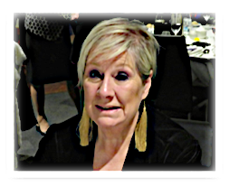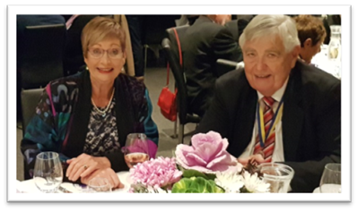

Above: Mikki Bouchee Above: Aileen and Allan Scott
Shortly after, Kerry Erasmus and Jung Grewal were inducted as new members to the club

This year, the club continued to focus on the three strategic priorities outlined in Rotary International President Barry Rassin’s presidential citation:
- To support and strengthen our clubs
- To increase humanitarian service
- To enhance Rotary’s public image and awareness

One of my main objectives for the club this year has been a focus on local initiatives, supporting the homeless and those in need. Achieved with the amazing support and enthusiasm of Jennifer Dowdy, the community spirit has really forged ahead.

In July, we started the year supporting Foodbank at Marion and West Lakes, by encouraging the public in these shopping centres to donate goods such as non-perishable items, toiletries and so-on.
We also collected items for “Rumbling Tummies “where 220 kgms of food was delivered, equating to 440 meals.
A second delivery for the Foodbank drive collected approximately 500 kgms of food equating to 1,000 meals. In total, the drive provided 2,000 meals. 50 – 60 bags of goods were also collected for HYPA: “Helping Young People Achieve”
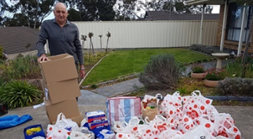

Wayne Dyson
with HYPA
donations

PRESIDENT'S REPORT 2018-2019 continued:

This year, the club’s signature event, the Cold Plunge, which supports the homeless, was the coldest plunge yet. That did not hinder the diehards who still plunged for a great cause. Noodle the Labradoodle became our mascot. We also found ourselves on all the TV stations on the Sunday.
The recipients of this year’s Plunge were, Catherine House, Hutt Street Centre, Magdalene Centre and Mary’s Kitchen. Once again, Jennifer Dowdy and her team did an amazing job in providing the baked goodies for the cake stall.
A huge thank you also to the Glenelg Surf Life Saving Club who looked after us as the waters became quite turbulent during the morning.

Our focus on local grassroots charities continued with support for AJ and “Our Street Family Matters”, providing goods and assisting with a special breakfast for the homeless. This will become a quarterly event on the club calendar. We also supported Eman Rahim who founded “Heart and Soul”, a free food market for those in need by volunteering at the markets. In October, 15 boxes of items were delivered to “Back Packs 4 SA Kids”. Items included household goods for starting out packages, colouring in books and pencils and clothes with an estimated value in excess of $1,000. HYPA have also been recipients of donations thanks to the wonderful efforts of Jennifer Dowdy.

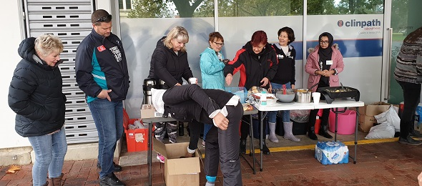

Presidents Alan Larkin of Holdfast Bay, Bill Rawlins from Somerton Park and I, “the Three Amigo’s”, set about getting together for a fundraiser, providing a BBQ for the Porsche Club. It has been great seeing clubs working together and we are looking forward to continuing our joint ventures. Adelaide University Rotaractors joined us in helping out at Our Street Family Matters special breakfast
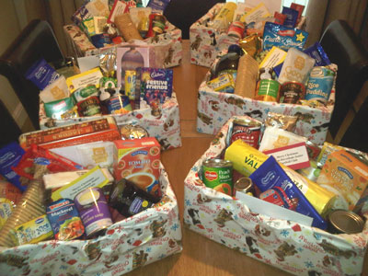
In November, the Christmas spirit was well and truly alive. The Christmas float was brought out of hibernation in preparation for the Glenelg Christmas pageant which brought Father Christmas to Glenelg. The club also fed the masses with a BBQ which was held on the esplanade.
Christmas is a time for giving. Alison Rogers and her team sewed Santa Sacks which were filled with goodies and donated to disadvantaged children in our community. A Christmas gift drive was also established, collecting gifts which were donated to teenage boys
Jennifer Dowdy set up a Christmas biscuit drive, baking amazing and delicious goodies and proceeds going to the purchase of 10 Foodbank Christmas hampers. The club also donated 10 Christmas hampers.

PRESIDENT'S REPORT 2018-2019 continued:

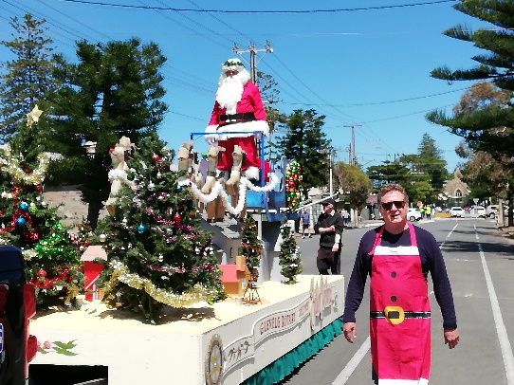

Kerry Erasmus at our Christmas Parade

This year Environment came onto the club’s agenda with “The Last Straw” campaign in working with local hotels in eliminating or reducing the use of plastic straws.
The club purchased paper straws and set about targeting venues on Jetty Road and worked on converting them from using plastic straws and in place we provided them with our paper straws.
There are many venues along the coast and we continue to spread the word on plastics.
The International committee has continued to support a variety of projects during the year.
A small team assisted at this year’s Donations in Kind Working Bee which included shoe sorting, packing boxes of flat shoes to go overseas and fashion shoes for sale, looking for proper bed heads for electric beds, in order to send the bed as a whole unit and working in the in the stationary room

Through a local fundraiser and a district grant, the club was able to provide 100 Bednet Buddy nets for distribution by Because International to children in Ethiopia.

One of the club’s continued sponsorships is that of sponsoring a teacher in Tanzania through the School of St Jude which provides free, high quality education to approximately 1,800 of the poorest and brightest students and provides gainful employment to about 300 local men and women in Tanzania.

Heather Earle attended a Working Bee in October to help with packing, cutting, ironing, and compiling sewing kit components for Days for Girls. $500 worth of material was donated. We had the pleasure of President Rose Milton from RC Bordertown, who spoke at a club meeting on her experiences with distributing the DFG kits overseas.

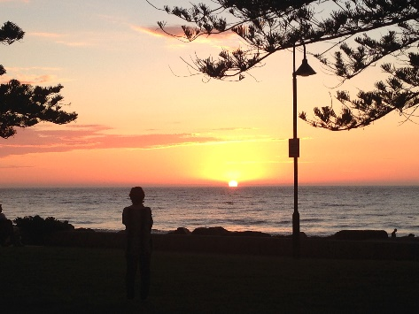
One of our favourite international fundraisers is Sunset Drinks on the Esplanade, kindly hosted by Diana and Peter Heysen at their apartment on the esplanade.

There’s nothing like watching the spectacular sunset with a glass of bubbles with great company and food.

PRESIDENT'S REPORT 2018-2019 continued:

The Thai Festival and Cultural Association of South Australia held its Loy Krathong Festival on Patawilya Reserve and the club was again approached to help out with a fun event, the Duck Race where 2,000 plastic ducks are hauled over the bridge and it was the first duck across the line. We then had to collect all the ducks from the water. Thankfully the ducks made their way to the banks of the river
The club continued to support Maternal Clinics in Cambodia by making a $500 donation to RC of Kent Town. Greg Dalton addressed the club about its work.
Following the success in previous years of the Shoe that Grows project, it was decided to promote it again this year at a Coles BBQ and by the “Wear a Pair” campaign. Sarah Walsh promoted the project and RC St. Peters donated $500. With Sarah’s fundraising campaign which raised over $1,000 and the club’s donation of $500, we were able to provide 100 pairs of shoes to children in need.
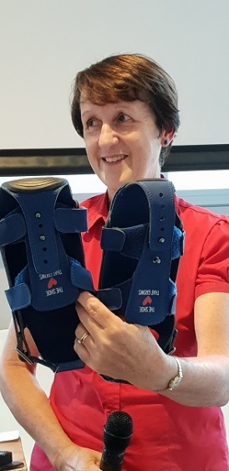

We continue to support Polio with an End Polio fundraiser and the club will make a donation of $500

Youth are our future and it is up to us to provide opportunities for them. The club continued to support a range of youth programmes including RYLA, RYPEN and National Youth Science Forum by promoting these initiatives in schools and sponsoring students
Shelter Box was again promoted at a Coles BBQ and the club has this year donated one shelter box.
We had the pleasure of sponsoring several students at the various Rotary youth programmes including Subhashree Murali at RYLA, Roger Hornett at RYPEN, Ben Viney for NYSF and One and All Sailing experience. We were privileged to have these young people visit the club and present on their experiences

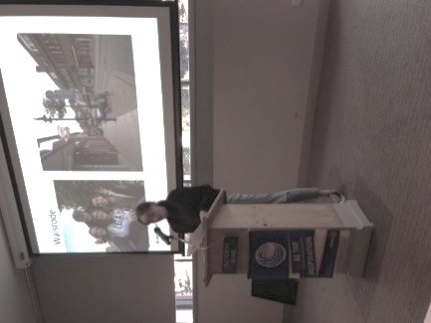
Shannon Denneny, pictured above, our long-term youth exchange student, returned from a year in Germany and spoke to our club about her host families and her amazing experiences and adventures while in Europe.

Mariella Hocking and Meridith Beaston presented Good Citizenship Awards this year to deserving students who had completed their final year of Primary School; two students from at St Leonards and two students from Plympton International College.

PRESIDENT'S REPORT 2018-2019 continued:

The students were each presented with a certificate and a $50 Dymocks book voucher at their final assembly of the school year.
This year, we donated $500 to the Sir Charles Bright Scholarship Trust which supports students with disabilities and are studying at tertiary level. They are supported with a financial scholarship to assist with some education expenses.

One of the club’s goals is to establish and sponsor an Interact club. Several schools have been approached and we continue to work towards this goal.
Lynne Pullman’s fabulous idea of collecting tinnies to raise funds to support youth programmes raised almost $1,000 this year.
There have been a number of fundraisers including a special three course dinner which was catered for by Jennifer Dowdy and her team.
Funds from this evening, $1,000, were donated to the Farmer’s Drought Relief Fund. Our fabulous honorary members, Audrey and Arthur Porter donated $2,000 towards the fund.

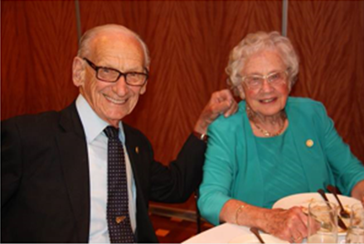

Arthur and Audrey Porter, pictured above, donated $2,000 to the
Farmers Drought Relief Fund

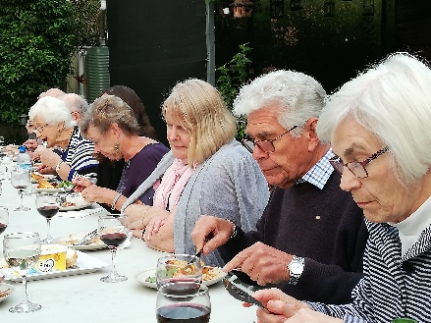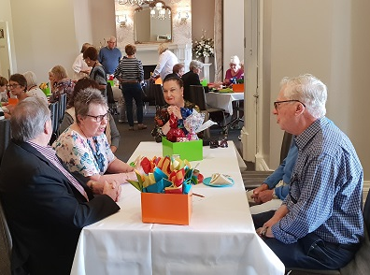

A special morning high tea, organized by Maxine Spencer, was held at Partridge House, and raised over $1,500 for Back Packs 4 SA Kids. Australian Rotary Health received a donation of $1,000. Part of the amount was raised through the Eisteddfod BBQ.A donation of $4,000 was also made to The Rotary Foundation.
One of my goals was to improve public image due to concerns about our presence on social media and the website. I asked Kerry Erasmus to revisit these areas and I am extremely excited by our advancement into social media. I wish to thank Kerry Erasmus, who tirelessly put in an endless number of hours in revamping our Facebook page and our new website and setting us up on Instagram and he continues to maintain them.
These avenues are directed at prospective members and volunteers, showcasing our club and what it does. Remember to check us out on rotaryclubofglenelg.com

PRESIDENT'S REPORT continued:

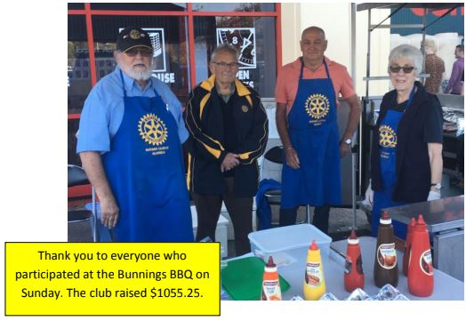
With our ongoing fundraising activities through local Coles and Bunnings BBQ’s, we are able to support projects and help out with local initiatives. A huge thank you to Wayne Sachs and his team for their continued dedication with these.

BBQ’s

Our Fellowship activities included a Guess Who’s Coming to Dinner (one of the club’s favourites), a new Member Information evening, a twilight cruise on the One and All, Christmas dinner at the Glenelg Golf Club and the New Year dinner held at the home of David and Pam Binks which was catered for by the Texas Bull Machine.

Thanks to Kerry Miller who organized a variety of guest speakers throughout the year. Speakers included Anna Dodd from HYPA, Alba Rodriguez, our New Generations Exchange student; Dr James Muecke who spoke about Alleviating Blindness in Asia and Rachael Zaltron from Back Packs 4 SA Kids.

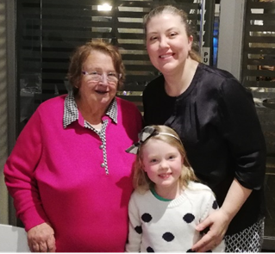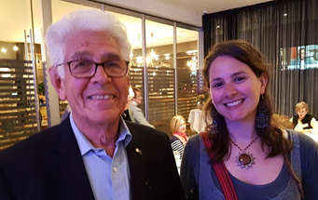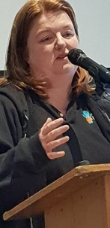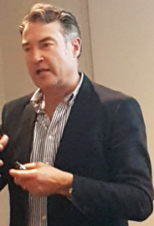

Jenny Dowdy with Anna Dodd David Binks with Alba Rodriguez NGSE Rachel Zaltron Dr. James Muecke

Also, thanks to Mariella Hocking who has done a wonderful job of preparing our club meetings and “Meals on Wheels” rosters.

I would also like to thank those who have helped with the registration table, set up at meetings, our MC’s and club members. Your contributions are greatly appreciated.
And lastly, I would like to thank the committee Directors for their contributions and support.

Looking back now, it has been a big year and I look forward to continuing with our focus and drive on local initiatives, supporting the homeless and those in need next year.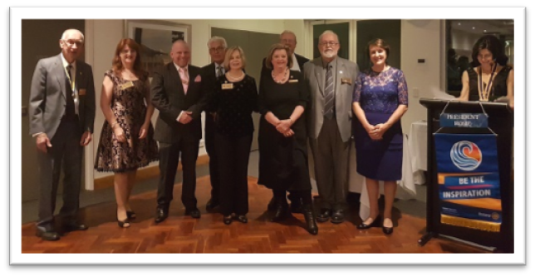

Rosie Erasmus
President

The new Board members with Rosie

CLUB ADMINISTRATION REPORT 2018-2019

Once again, administration functioned smoothly and I would like to thank the team who ensured that club meetings and activities ran smoothly throughout the year.

Our team:

Kerry Miller who ensured a roster of guest speakers and at times proved a little challenging however Kerry did a fabulous job in accommodating requests for speaker spots. There is definitely no shortage of speakers.

Kerry was also responsible for attendance and liaising with the Holdy on numbers. There were times when it didn’t quite pan out however it always works out in the end.

Mariella Hocking has done a wonderful job in not only looking after our club rosters; she has also looked after our meals on wheels roster. And as usual, everything has been under control under Mariella’s watch.

Ollie Bullitis took over the weekly Rota News from Rosie Erasmus. With the assistance of Meridith Beaston who agreed to take minutes at the meetings and Wayne Sachs who stepped in at times in sharing the load is a good example of support in the club.

Kerry Erasmus took on the revamping of our Facebook page, website and set up an Instagram account for the club thereby lifting our profile on social media. This is an ongoing commitment in ensuring that our social media presence is current.

Our MC’s have included Heather Earle, Kerry Miller, Maxine Dunn, Maxine Spencer, Tony Colliver and our newest MC, Mikki Bouchee. They have done a wonderful job in the smooth running of our meetings.

An important job is the insurance and compliance aspects of our club and I would like to thank Nigel Woolmer for his continued support.

A BIG thank you to the Club Administration team for your fabulous support and commitment.

I would also like to thank those who have helped with the registration table, set up at meetings, other tasks as requested and our club members.
Each of your contributions is greatly appreciated.

Rosie Erasmus
Club Administration Chair

COMMUNITY SERVICE REPORT 2018-2019

Rotary is a service organization and I am pleased to say that the spirit of service has continued.

This year, the club’s signature event, the Cold Plunge, which supports the homeless, was the coldest plunge yet. Our Glenelg Surf Life Savers looked after us and made sure that everyone was safe in the water. Recipients of this year’s Plunge were Catherine House, Hutt Street Centre, Magdalene Centre and Mary’s Kitchen.
An amazing effort and a huge thank you to Jennifer Dowdy and her team who once again provided a fabulous array of baked goodies for the cake stall, Wayne Sachs and the BBQ team for providing much need nourishment for plungers and supporters, all the volunteers who helped on the day braving the cold and needless to say, those that took the PLUNGE, a massive thank you.

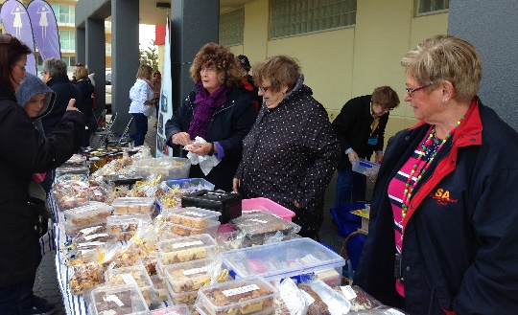

Community spirit continued throughout the year with deliveries to our local causes, Foodbank and Rumbling Tummies where 500 kgms of food items were delivered equating to 2,000 meals. 50 – 60 bags of goods were also collected and delivered to HYPA (Helping Young People Achieve).

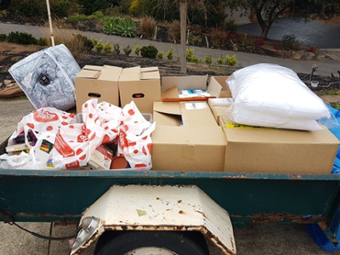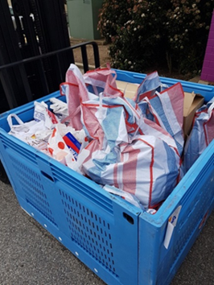

Back Packs for Kids received 15 boxes of items which included household items for starting out packages, colouring in books and pencils and clothes with an estimated value in excess of $1,000. Thanks to the two Waynes and Jennifer.

AJ from Our Street Family Matters and Eman Rahim from Heart and Soul spoke at our club and were presented with boxes of goodies to help those in need.

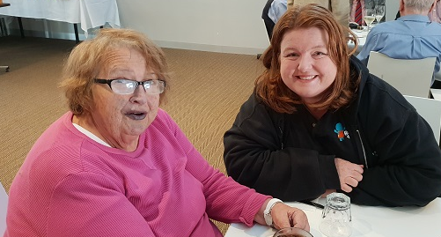

COMMUNITY SERVICE REPORT 2018-2019 continued

Club members and Adelaide University Rotaractors volunteered at a special breakfast for the homeless provided by Our Street Family Matters. Club members also helped at a Free Food Market held by Heart and Soul. Another combined volunteer event in conjunction with RC Holdfast Bay and RC Somerton Park was held again volunteering at The Free Food Market.
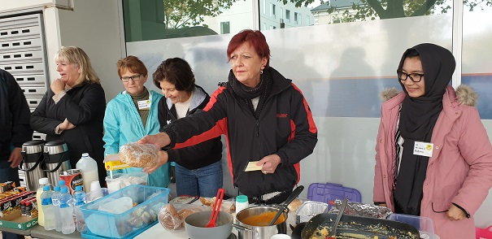

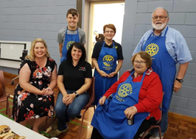

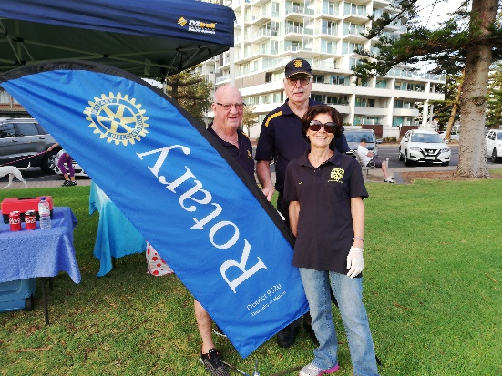
Presidents Alan Larkin, of Holdfast Bay, Bill Rawlins from Somerton Park and myself, “the Three Amigo’s” set about getting together for a fundraiser, providing a BBQ for the Porsche Club.

The Christmas spirit came alive in November starting with the Christmas float which was brought out of hibernation for the Glenelg Christmas pageant bringing Father Christmas to Glenelg. As always it is such a pleasure to see the cheer and joy of excited kids (and parents) when the Big Guy in the red suit passes them.
The club also fed the masses with a BBQ which was held on the esplanade.
Alison Rogers and her team upheld the spirit of giving as they sewed Santa Sacks and filled them with goodies and donated to disadvantaged children in our community.
A Christmas gift drive was also established, collecting gifts which were donated to teenage boys.
Jennifer Dowdy set up a Christmas biscuit drive, baking amazing and delicious goodies with proceeds going to the purchase of 10 Foodbank Christmas hampers. The club also donated 10 Christmas hampers which were distributed to the needy in our community.

COMMUNITY SERVICE REPORT 2018-2019 continued

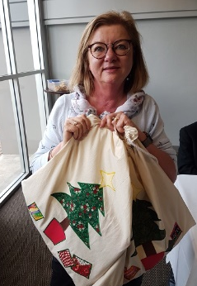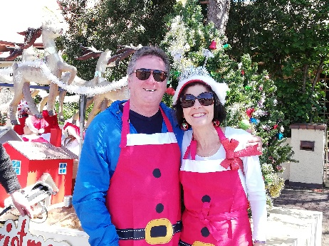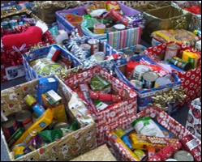
Several fundraisers were held raising funds for specific causes. A special three course dinner was organized by Jennifer Dowdy and her team. It was a lovely evening set in the gardens of Ollie’s parent’s home. An amount of $1,000 was raised and donated for the Farmer’s Drought Relief Fund. We also thank Audrey and Arthur Porter for their amazing generosity in donating $2,000 for the Farmers.

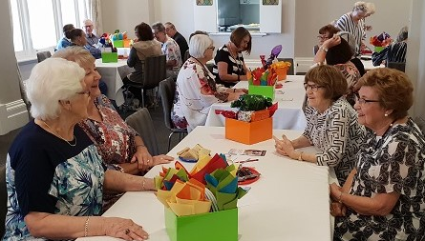
Back Packs 4 SA Kids received a donation of $1,515 from funds raised from very successful morning High Tea held at Partridge House and organized by Maxine Spencer and her team.

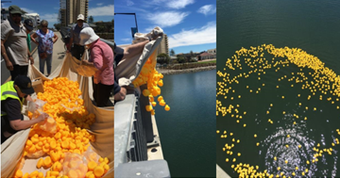
The club was again approached by The Thai Festival and Cultural Association of South Australia to help out with their annual event, the Duck Race where 2,000 plastic ducks are hauled over the bridge and make their way across a finish line.

In February, it was time to give our trusty BBQ van a complete overhaul. A working bee was held where the van was emptied, cleaned throughout, old bits and pieces thrown out and the exterior of the van given a facelift with new signage thanks to Mark Cleary.
We were rewarded with a lovely lunch provided by Wayne’s wife, Mary and Jennifer.

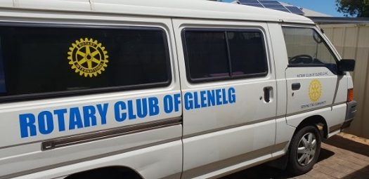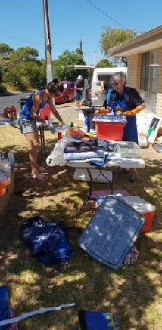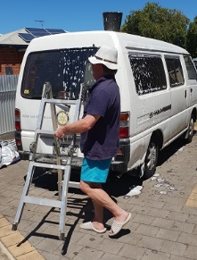

COMMUNITY SERVICE REPORT 2018-2019 continued

With our ongoing fundraising activities through local Coles and Bunnings BBQ’s, we are able to support projects and help out with local initiatives. A huge thank you to Wayne Sachs and his team for their continued year-round dedication on the BBQ’s.

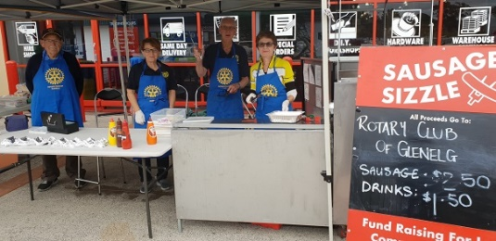
With our ongoing fundraising activities through local Coles and Bunnings BBQ’s, we are able to support projects and help out with local initiatives. A huge thank you to Wayne Sachs and his team for their continued year-round dedication on the BBQ’s.

We must truly thank club members who volunteer as drivers through Meals on Wheels, delivering meals for our elderly.

Jenny Dowdy
Community Service Chair
(Report compiled by Rosie Erasmus)

MEMBERSHIP REPORT 2018-2019

Committee members: Kerry Miller, Wayne Dyson, Graham McRae and Mikki Bouchee.
I am pleased to say that this year’s membership has realized an increase of four new members.

At the Changeover Dinner in July Mikki Bouche was inducted followed in August by Kerry Erasmus. In November Jung Grewal was welcomed into the club.

It was with regret that Rada Radisic and Mark Cleary have relinquished their membership. Rhona Finn has moved to Melbourne to work. Jessie Vun is now living in Sydney and Mariella Hocking is totally committed looking after her 104 year-old mother. As a result all three have had to resign their memberships. Sharon Langston has also resigned.

Membership has been a challenge to all service clubs at both local and national levels. On the other hand some clubs within our District have grown their membership numbers significantly over the last few years.

I had the privilege to attend a recent District Membership Forum held at Flinders University. The forum was without doubt the best run and presented membership campaign I have been to. It demonstrated successful membership growth pathways. I have developed a membership campaign to be instigated in the first few months of the 2019-20 year pursuing these pathways. A lot of my focus this year has been working with Alan Larkin, President of the Holdfast Bay Rotary Club, developing a plan which I am hopeful of presenting to businesses to encourage them to become Community Partners with the Glenelg Rotary Club. The focus is encouraging businesses to pursue their Community Service obligations through programs already in place within Rotary and at the same time offering involvement in many future Rotary projects.

Public Image
Kerry Erasmus has set up a new Facebook site for Glenelg Club, which was launched in early May. Kerry has been working hard to incorporate on it a lot of information about the Glenelg Rotary Club’s programs as well as incorporating information for members and followers.

Mikki has developed a working relationship with the Mayor of Holdfast Bay Council to promote our events on the Mayor’s weekly radio broadcasts. There are also plans in place for a promotional banner to be displayed in Mosley Square.

Mark Cleary printed club polo shirts for members to wear at club events promoting the club. In addition Mark has organised a display banner for use at our BBQ’s. The new signwriting for the van has helped lift our public image. This was also organised by Mark.
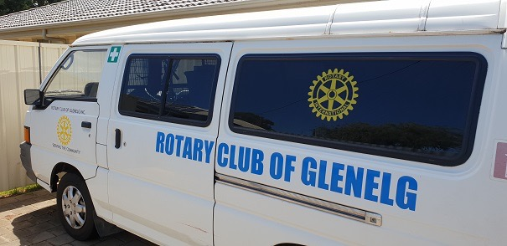
I wish to thank the members of the Membership committee for their help and input this year. They have been a great sounding board which I relied on during the development of the Community Partners program.

Bill Walsh
Membership and Public Relations Chair

ROTARY FOUNDATION REPORT 2018-2019

The Rotary Foundation is best described as the “charity of choice” for Rotarians.

As the charitable arm of Rotary, we tap into a global network of Rotarians who invest their time, money, and expertise into our priorities, such as eradicating polio and promoting peace.

Foundation grants empower Rotarians to approach challenges such as poverty, illiteracy, and malnutrition with sustainable solutions that leave a lasting impact.
Since it was founded more than 100 years ago, the Foundation has spent more than $4 billion on life-changing, sustainable projects.
During the past twelve months the club has committed $4,000 to the Rotary Foundation, surpassing the expectation of contributing $100 per member.

Many members also commit to donating $100 per year to the Centurion Club giving their own personal commitment to Rotary through the Australian Rotary Trust.
This arm of Rotary gives a tax deduction to members for their donation.

The Rotary Club of Glenelg is proud of its annual achievements, with this financial year being no exception.
Its members continue to see the importance of donation to the Foundation so that
Rotary can continue making a difference in our world.

Alison Rogers
Rotary Foundation Committee Chair

FELLOWSHIP REPORT 2018-2019

Fellowship in the Glenelg Club remained strong during the year. A somewhat larger number of hands-on fundraising activities added to the spirit of camaraderie in the club. It also resulted in slightly less functions being carried out by this committee. As enthusiastic as they may be, there is a limit to the amount of time members have to be involved in Club activities.
The following events were held and proved popular.

Changeover Dinner 5th July
This event held at the Glenelg Golf Club for President Sarah to hand over the reins of the club to incoming president Rosie again proved extremely popular. Over 80 attended including members, their guests and friends together with Rotarians from other clubs including a group of past district governors. The food and service was again of a high standard.

New Members’ Information Night 24th August
A group of 6 new members gathered at David Binks’ home at 7:30 on the Friday night. In a convivial atmosphere David and a group of experienced club members explained a little about the functioning and history of our Rotary Club. This was followed by the structure of Rotary at a district and international level. They also talked a little about the history, some of Rotary’s great achievements and some of the programs which Rotary runs.

NGSE speaker 12th September
Alba Rodriguez our district New Generation recipient from Spain spoke at a club meeting. Alba is a fully qualified vet who came on exchange to learn more about our native animals and how to treat them. She told how she was fascinated with koalas, kangaroos, wallabies, wombats etc. She also explained a little of her life as a vet in Spain, some of what she had already done in Australia and some of what she still hopes to do before she goes home.

Guess Who's Coming to Dinner 15th September
This popular event, which keeps both the guests and the hosts guessing where they are going and who will be coming, was again a great success. The hosts always seem to provide superb meals. This along with the favourite bottle of wine the guests bring to share makes for a fun-filled evening full of conversation. Once again after this year's event the comment "you get to know fellow Rotarians far better at an evening like this than you do at club meetings and events" was widely expressed.

Bubbles at Sunset 23rd November
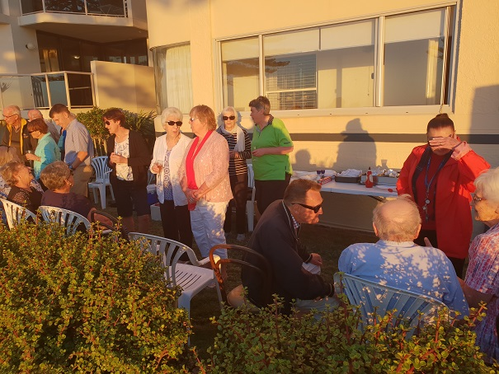
Peter Heysen again for a second year organised bubbles and food for the club on the Esplanade in front of his unit on a delightful summer's evening. We were able to watch the sun dip below the horizon while enjoying champagne and a range of other beverages as well as a finger-food dinner. This proved a most pleasant evening which also raised a little money for Peter's International Committee.

FELLOWSHIP REPORT 2018-2019 continued

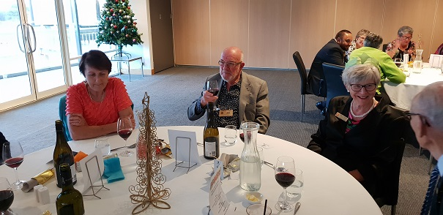
The Christmas Function 13th December
This was again held at the Glenelg Golf Club. Due to midweek golf, we celebrated on Thursday rather than Wednesday. The smaller less elaborate function than our Changeover Dinner was attended largely by club members and partners. The atmosphere, view and camaraderie made it an evening most attendees really enjoyed.

First Night Back Barbecue 9th January
This event which traditionally welcomes Rotarians back after the brief summer break was held this year at David and Pam Binks home. Tables and chairs courtesy of Paul and Annie Dale were arranged under the large spruce tree in the front yard. Flickering lights in the tree created a festive atmosphere and again the staff of Texas Bull machine served us a delicious meal.

District Conference 5th to 7th May
Many of our club members were away travelling at this time and as a result the attendance at the conference was very small. Rosie and Kerry, Lynne Pullman and Alison Rogers came along with Pam and David Binks. The conference was held in district Governor Kim's hometown of Broken Hill. The conference was an excellent one with some exceptional speakers and good social events.

David Binks
Fellowship Chair

INTERNATIONAL SERVICE REPORT 2018- 2019

The International committee has continued to support projects which we believe follow the ethics of Rotary.

The School of St Jude provides free, high quality education to approximately 1,800 of the poorest and brightest students and provides gainful employment to about 300 local men and women in Arusha, Tanzania.
We sponsor a teacher to the value of $720 a year. This is often topped up to $1000. We raise this money through loose coin donations from members at our weekly meetings.

Days For Girls provides sustainable feminine hygiene to girls and women who would otherwise go without. They aim to create a more dignified, free and educated world through access to lasting feminine hygiene solutions.
Heather Earle attended a Working Bee this year to help with packing, cutting and ironing, and compiling sewing kit components. We have also donated $500 worth of material, and Maxine Dunn arranged for a friend of hers, President Rose Milton of RC Bordertown, to speak to us on her experiences with distributing the DFG kits overseas.

Maternal Clinics in Cambodia. Our committee agreed to continue our support for this project run by RC Kent Town. We were given further information in a presentation by Greg Dalton and donated a further $500 to help him pursue the second stage of the project. There is the opportunity for members to volunteer in Cambodia.

Bednet Buddies. The bednet is a free-standing tent that can be used anywhere to protect children aged 0-5 years from mosquitoes and malaria throughout Africa. The nets ae designed to last 10 years and should provide immediate benefit.
The project was promoted at a Coles BBQ and a Galleon Theatre night fundraiser, where club members co-mingled with the general public. With the aid of a District Grant for $960 and a contribution of a further $1040, we were able to provide 100 nets for distribution by Because International to children in Ethiopia.

Sunset Drinks on the Esplanade. This was a successful social event hosted by Peter Heysen which enabled us to boost our committee’s finances.
We have also sold some wine and socks as additional fundraisers and donated items to be sold on EBay.

Shoes That Grow Following the success over the last few years of the Shoe that Grows project, it was decided to promote it again this year at a Coles BBQ and by the “Wear a Pair” campaign. Sarah Walsh spoke to RC Campbelltown to provide them with more information about the project and also to RC St. Peters, who responded with a $500 donation. Sarah’s own fundraising campaign raised over $1000 and the club donated a further $500. The shoe that grows adjusts and expands 5 sizes and lasts for years. Over 300 million kids don’t have a pair of shoes that fir or don’t have a pair at all. We were able to provide 100 pairs of shoes to children in need.

ShelterBox helps turn despair into hope following disaster. The sturdy green box is filled with practical items, designed to help people who have lost everything: a family tent, tools, utensils and materials to help families repair their houses, emergency water

INTERNATIONAL SERVICE REPORT 2018-2019 continued

purification, solar lights. $1000 gives a family shelter and relief from the chaos of disaster and conflict. We promoted ShelterBox at a Coles BBQ and have donated one box this year.

Polio. The campaign to eradicate polio worldwide continues and still needs support as it nears the end. It is proving very difficult and dangerous to administer the much-needed vaccine in Pakistan and Afghanistan, so we are continuing to raise money and awareness for this campaign. This year, the committee will donate $500, raised from a Coles BBQ and miscellaneous sales.

Australian Rotary Health. Although this is not an international project, we were happy to raise money from the Eisteddfod and the BBQ at the Eisteddfod to donate a total of $1000.

Sarah Walsh
International Chair

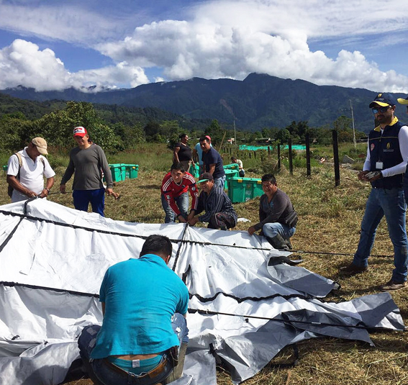

YOUTH COMMITTEE REPORT 2018-2019

Committee members: Lynne Pullman, Mariella Hocking, Michelle Aylen, Diane Heysen, Graham McRae and Meridith Beaston

During this busy year, we were happy to offer support for young people through several Rotary Youth Programs. We budgeted to spend $6,955 and spent $4,275.

RYLA: September 2018
This youth leadership training program is delivered over a week at the Nunyara Conference centre Belair in the Adelaide hills. The program focusses on citizenship, personal growth, ethics and communication skills for potential leaders.
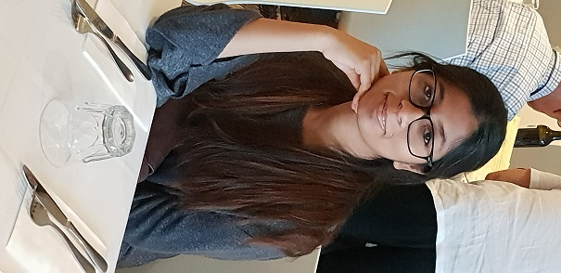
We were pleased to sponsor applicant Subhashree Murali pictured below, to attend the camp. She had recently arrived in Adelaide from Mumbai and had commenced her first year in Structural Engineering at Adelaide University. Her application and subsequent interview indicated her firm commitment to her chosen subjects and her keen interest in learning more about developing leadership skills and networking with other students with similar interests in engineering. Subhashree thoroughly immersed herself in the workshops and activities offered at the camp and was keen to speak to our club about being inspired and motivated by the guest speakers and participating youth leaders. As a club, we were pleased to applaud her at the RYLA graduation dinner, held at the Glenelg Surf Life Saving Club. Her knowledge and understanding of the work of Rotary continuing through her active membership of Rotaract at Adelaide University.

Good Citizenship Awards: November 2018
Mariella Hocking and I were pleased to present Good Citizenship Awards this year to deserving students who had completed their final year of Primary School. The award formally acknowledges that selected students have demonstrated many of the attributes of good citizenship during their time at their school. This year, two students from St Leonard’s Primary School and two from Plympton International College students were each presented with a certificate and a $50 Dymocks book voucher at their final assembly of the school year.

NYSF: Orientation September 2018 and Canberra Trip January 2019
The National Youth Science Forum is a 12-day residential program designed to give students a broader understanding of the diverse study and career options available in science, engineering, technology and Maths.
After considering his application, we sponsored Flinders University School of Maths and Science Year 11 student, Ben Viney, who was very fortunate to be offered a place in the second round of selection. He attended the Orientation Day and was most inspired by the presentation given by Dr. Bob Basedow, who has been the chief engineer for the Hubble Space Telescope’s optical assembly.

YOUTH COMMITTEE REPORT 2018-2019 continued

Ben’s formal report to us revealed that his active participation in the program in Canberra certainly helped him explore tertiary courses and further avenues of study he had not previously been aware of or considered.

He made friends and established connections with several students with similar interests.

“One and All” Rotary Sailing Challenge
Year 11 student from the Flinders University School of Maths and Science, Ben Viney, applied for the sailing experience after not being selected in the first instance for the NYSF. His application for the sailing program was accepted and Ben set about his preparations for the 5-day voyage with a positive mindset. As a student trainee, he was required to work with his peers and crew to apply effective team work, self- discipline and to observe and practice various sailing and navigation skills.

During his final day on board, Ben wrote an insightful account of his voyage, focussing on what he had learned about key elements of the ship’s environment and operation; as well as facing his own mental and physical challenges relating to a sailing program of such magnitude. Ben sincerely thanked us for our sponsorship. On his return, Ben shared his final report with us at a club meeting.

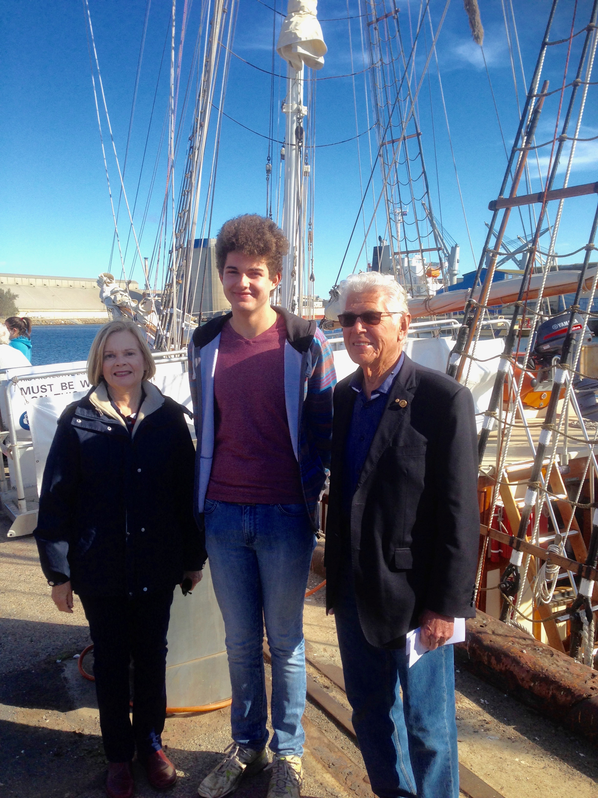
RYPEN: Camp at Belair: April 2019
We were pleased to receive an application from Brighton Secondary School student, Roger Hornett, to participate in this years’ RYPEN camp at the Nunyara conference centre Belair.
This weekend program is for 14 to17 year old’s who are keen to learn more about problem solving, public speaking and confidence building. Roger put these skills into practice through debates and various activities.
He was pleased to share his experiences at RYPEN with our club members, with an engaging, informative talk and photo presentation.

Meridith Beaston with Ben Viney and David Binks alongside the One and All sailing vessel at Dock 2 Pt. Adelaide.

YOUTH COMMITTEE REPORT 2018-2019 continued

Donations: Supporting Youth
This year, we donated $500 to the Sir Charles Bright Scholarship Trust. This Trust supports students with disabilities who are studying at tertiary level. They are supported with a financial scholarship to assist with some education expenses. The Scholarships are managed by the Trust Board which raises the funds. The amount raised each year determines the number of scholarships that can be awarded as this organisation receives no government funding. The Trust Board communicated their appreciation of our support for young people engaged in tertiary studies.

Interact
A handbook and information brochure about Interact were sent to the Brighton Secondary School and Plympton International College together with a letter outlining our proposal of possibly of our club sponsoring an Interact Club at these schools. No response has been received from either school at this time.

Fundraising
Lynne Pullman coordinated our ongoing fundraiser for our youth programs: “Tinnies for recycling” which raised $1000.

I sincerely thank all our committee members for their contributions during this Rotary year. With these, we have established sound relationships with several schools in our area. Teachers we have regularly contacted have shown interest in our youth programs; sharing particular information with their colleagues and interested students.

Below: President Rosie Erasmus, Meridith Beaston and RYPEN participant Roger Hornett.

Meridith Beaston
Youth Programs Chair

FUNDRAISING REPORT 2018-2019

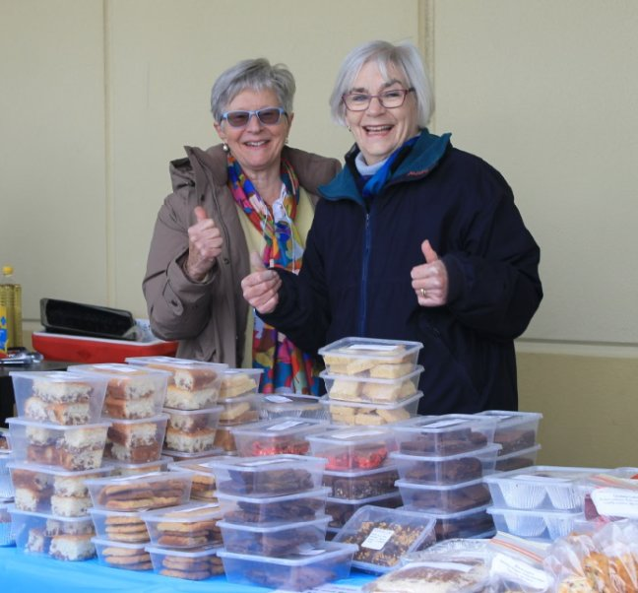
Several fundraising events were held during the year, supporting a range of worthy causes.

Our fund-raising calendar for the year started with our signature event, The Cold Plunge, our coldest plunge event yet, which was held in August. This is our biggest annual fundraiser which raises much needed funds for the homeless.

Organised by Sarah Walsh, a BBQ was held at the at the Music Eisteddfod and funds raised were donated to Australian Rotary Health.

The plight of the drought-stricken farmers was highlighted during the year. Jennifer Dowdy and her wonderful team, organized a delicious three-course dinner, hosted by Oliver Bullitis, in his parent’s garden. Over $1,000 was raised and donated.

The international committee held fundraising activities to raise funds for Bednet Buddies, with a Coles BBQ and a Galleon Theatre night fundraiser. With the aid of a District Grant for $960 and a contribution of a further $1,040, the club was able to provide 100 nets for distribution by Because International to children in Ethiopia.

Another international fundraiser, which has become an annual event, was Bubbles at Sunset on the Esplanade. A beautiful setting with great fellowship, food and bubbles.

Mark Cleary raffled a miniature Harley Davidson and other items at club meetings raising approximately $500 to go to general club revenue.

In February, Maxine Spencer and her team, organised a morning high tea, featuring some very delicious delicacies at Partridge House Glenelg. $1,500 was raised for Back Packs 4 SA Kids.

There have been sales of socks, wines and a new youth initiative by Lynne Pullman, collecting bottles and cans. This year the collection of tinnies raised almost $1,000.

However, our main fundraising income stream, which is instrumental in supporting many worthy causes, are our BBQ’s at Coles in Glenelg and Bunnings at Marion. These funds are used to support The Rotary Foundation, Shelter Box, The School of St Jude and our sponsorships of Rotary Youth programmes including RYLA, RYPEN, NYSF and other youth initiatives supported by the club.

A huge thank you is extended to Wayne Sachs and his team for their continued commitment to the success of the BBQ’s.

All of these fundraising activities provide an opportunity for club members to come together for fun and fellowship. Many of the world’s problems have been resolved at the Coles and Bunnings BBQ’s.

Rosie Erasmus
Fundraising

ROTARY CLUB OF GLENELG – PROGRAMMES 2018

July 4 | 3369 |  | Changeover
July 11 | 3370 | Social meeting
July 18 | 3371 | Social meeting
July 25 | 3372 | Board Meeting
August 1 | 3373 | Dr James Muecke | Sight for All
August 8 | 3374 | Social Meeting
August 15 | 3375 | Committee Meetings
August 22 | 3376 | Board meeting
August 29 | 3377 | DG Kim Harvey Visit
September 5 | 3378 | Anna Dodd | HYPA
Sept 12 | 3379 | Alba Rodriguez | New Generations Exchangee
Sept 19 | 3380 | Jessie Vun
Sept 26 | 3381 | Board Meeting
Oct 3 | 3382 | Emma Rahim | Heart and Soul
Oct 10 | 3383 | Damian Leach | Interact Clubs
Oct 17 | 3384 | Committee Meetings
Oct 24 | 3385 | Board Meeting
Oct 31 | 3386 | Club assembly
Nov 7 | 3387 | Ben Viney  Subhashree Murali | One & All Challenge  RYLA
Nov 14 | 3388 | Social Night | Oliver Bullitis’ residence
Nov 21 | 3389 | Committee Meetings
Nov 28 | 3390 | Board Meeting | Cold Plunge Presentations
Dec 5 | 3391 | Lynne And AGM | Recognise Stroke through FAST
Dec 13 | 3392 | Christmas Dinner
Dec 19 | 3393 | No meeting
Dec 26 | 3394 | No meeting

ROTARY CLUB OF GLENELG – PROGRAMMES 2019

Jan 2 2019 | 3395 | No meeting
Jan 9 | 3396 | Social Meeting | Binks residence
Jan 16 | 3397 | Committee Meetings
Jan 23 | 3398 | Board Meeting
Jan 30 | 3399 | Club Assembly
Feb 6 | 3400 | Rose Milton | Days for Girls
Feb 13 | 3401 | Rachael Zaltron | Backpack 4 Kids
Feb 20 | 3402 | Committee Meetings
Feb 27 | 3403 | Board meeting
March 6 | 3404 | Shannon Denneny | Overseas Youth Exchange Student
March 13 | 3405 | Aileen Jeffries | Our Street Family Matters
March 20 | 3406 | Committee Meetings
March 27 | 3407 | Board Meeting
April 3 | 3408 | Ben Viney | NYSF
April 10 | 3409 | Jim Blake | Discovery centre
April 17 | 3410 | Committee Meetings
April 24 | 3411 | Board Meeting
May 1 | 3412 | Joe Meuris | Water Project in Timor Leste
May 8 | 3413 | David Binks | Youth Protection
May 15 | 3414 | Roger Hornet | RYPEN
May 22 | 3415 | Board Meeting
May 29 | 3416 | Club Assembly
June 5 | 3417 | Alice Brooks | Orange Sky Laundry
June 12 | 3418 | Euan Miller | Membership
June 19 | 3419 | Committee meetings
June 26 | 3420 | Board meeting
July 3 | 3421 | Change Over

FINANCE REPORT 2018-2019

The accounts for FY 2018 were audited and signed off by Ian Mc Donald in October 2018.

FY 2019 accounts for the Rotary Club of Glenelg have been reconciled as at 24th June 2019.

The two main operating accounts are the Administration account and the Project account.

Club Administration account
As at 24th June the Administration account bank balance was $5,416.29.
Of this, currently $1,392 are proceeds received for the FY 2019 Change over dinner. This amount has been allocated to receipts in advance in the balance sheet

Activity for the year:

Income - Administration | Expenditure – Administration
Dinners - Change over $3,905  Dinners - Weekly $17,363  Donations / Fines received $434  Interest income $25  Membership Dues $9,438  $31,165 | Badges & Engraving $44  Bank Fees $49  Computer Expenses $147  Dinner expenses - Change over $4,290  Dinner expenses - General $15,530  Donation Rotary Foundation $4,000  Flowers and Gifts $106  Marketing and Advertising $273  New member kits-RDU $110  Postage & Post Box Hire $130  Printing and Stationery $302  RDU - subs (magazines) $1,660  RI Dues $7,728  Website Hosting $243  $34,611

FINANCE REPORT 2018-2019 continued

Club Project account
As at 24th June the Project account bank balance was $14,662.74 which includes an amount of $3,860 being a District grant for wheelchairs which has not been expended.
Activity for the year
 | Income | Expenditure | Nett income
Environment | $0 | $2,665 | -$2,665
LOCAL-ONE and ALL | $17,557 | $0 | $17,557
Proceeds-BBQ | $10,571 | $5,386 | $5,185
Proceeds-Cake sales | $2,485 | $0 | $2,485
Proceeds-Cold Plunge | $12,699 | $1,408 | $11,291
Proceeds-eBay | $503 | $213 | $290
Proceeds-Entertainment books | $1,710 | $1,344 | $366 | (invoice yet to be received)
Proceeds-Piggy | $811 | $0 | $811
Projects-Local | $10,097 | $0 | $10,097 | (includes District Grant  for $3,860)
Projects-International | $4,794 | $1,250 | $3,544
Proceeds-Tinnies collection | $1,034 | $0 | $1,034
 | $62,261 | $12,265 | $49,996

FUNDS DISTRIBUTED
Youth
NYSF | $3,150
One and All Sailing experience | $19,800
RYLA / RYPEN | $1,200
Sir Charles Bright Scholarship | $500
Student Citizenship Awards | $208
 | $24,858
Community
Australian Rotary Health donation | $1,000
Back Packs 4 SA Kids | $1,585
Cold Plunge - Catherine House | $2,480
Cold Plunge - Hutt Street Centre | $2,480
Cold Plunge - Magdalene Centre | $2,480
Cold Plunge - Mary's Kitchen | $2,480
Cold Plunge - Glenelg SLSC | $500
Farmers Drought Relief Fund | $1,000
Foodbank Christmas hampers | $920
Santa Sacks | $300
 | $15,225
FUNDS DISTRIBUTED continued

International
Bednet Buddies | $2,000
RC Kent Town Cambodia project | $500
RAWCS | $2,000
Shelter Box | $1,000
 | $5,500
Foundation | $4,000
Total | $49,583

Rosie Erasmus
Treasurer

